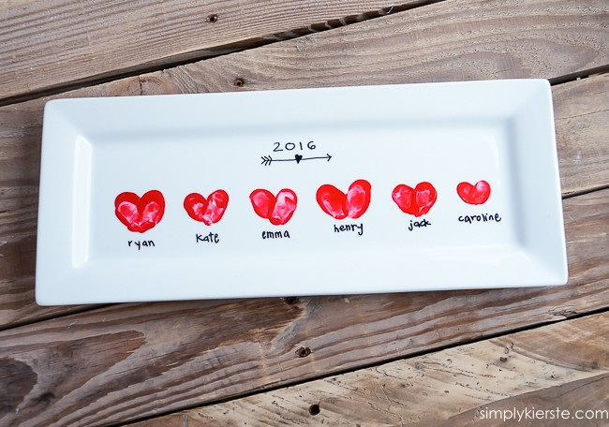

This one is super easy! Get a blank plate, or platter or coffee cup. The dollar store is a great choice! Make thumbprint heartprints of the kids in your family. Add names and dates with a fine tip sharpie.
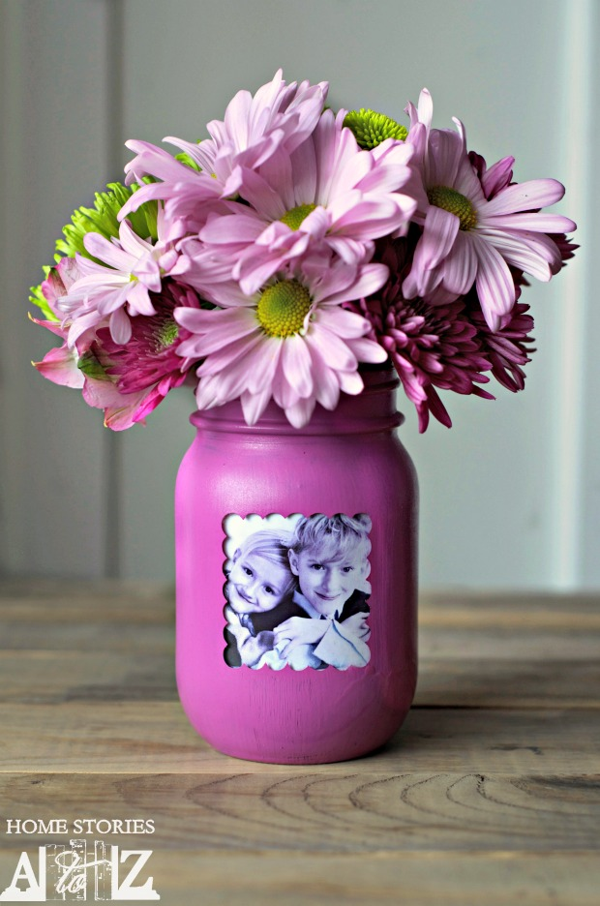

SUPPLIES NEEDED FOR MASON JAR PICTURE VASE
For this project you will need the following:
- Clean mason jar
- Paint
- Paint
- Vinyl shape or sticker and a picture she will love

STEP 1: PLACE VINYL OR PAINTER’S TAPE OVER JAR AND PAINT.
To create your picture frame window on your jar, place vinyl or painter’s tape on the area that you don’t want painted. I used my Silhouette machine to cut out a decorative square in black vinyl. There were some gaps in my vinyl, so I filled them with painter’s tape. If you don’t own a Silhouette, you could create a square using painter’s tape and decorative edge scissors. Paint the outside of the jar and immediately remove your sticker. You do not want to wait until the paint is dry or else it will be difficult to remove your sticker.

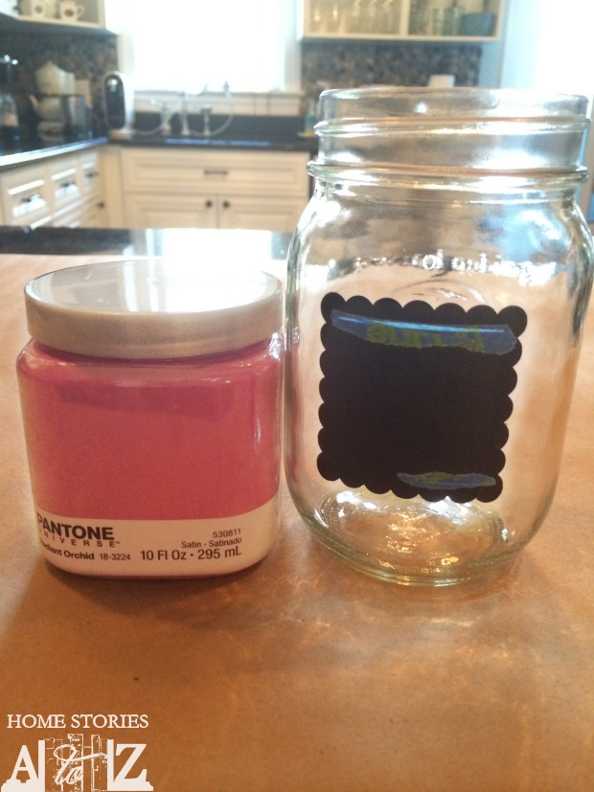Step 1 paint the jar except for where the picture goes.

STEP 2: CUT A PICTURE TO SIZE AND ATTACH TO JAR WITH PAINTER’S TAPE.
I tried out a few different pictures before deciding on the one I liked best. I sized my pictures in a Word document and then just printed them off on my laser printer. The painter’s tape allows you to easily change out the picture.
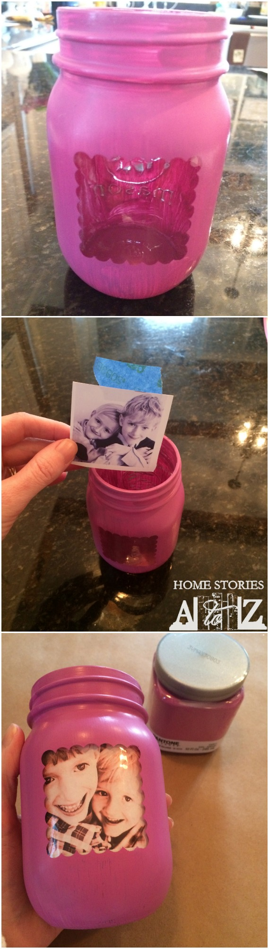Step 2 attach a picture to the inside of the jar.

STEP 3: PLACE PAPER CUP INSIDE JAR TO HOLD FLOWERS.
Your picture will be ruined if you fill the inside of the jar with water. Place a paper cup inside the jar, fill the cup with water, and place your flowers in the cup. I used a foam cup and had to cut off the lip of the cup in order for it to fit but it worked great.

BATH SALTS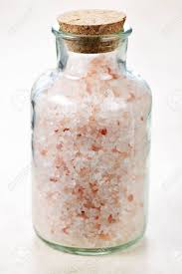
Ingredients:
1 cup of Epsom Salt (you can get this is this medicine part of Walmart)
Essential fragrance oil - - maybe rose, lilac, etc. (Walmart, Michaels or Hobby Lobby)
Blender
Jar and pretty ribbon

What you do:
Put Epsom salt and 2-4 drops of fragrance oil in the blender. Blend for a few seconds and pour mixture into the jar. Put the lid on and tie a pretty ribbon on the jar.

Bath/Shower Bomb

Ingredients:
1 cup baking soda
½ cup cornstarch
½ cup Epsom salt
4 tablespoons cream of tartar
2 ½ tablespoons coconut oil
Essential fragrance oil
Mold or muffin tin

What you do:
- Mix baking soda, cornstarch, Epsom salt and cream of tartar in a bowl.
- Add coconut oil and mix well.
- 3. Add ¾ tablespoon water and your choice of fragrance.
- Mix well and transfer to a mold. If you don’t have a mold, a muffin tin works.
- Let sit for 24 hours. The remove from mold and package in a pretty box or bag.

“GIFT CERTIFICATES”
Print the following page on paper or cardstock. Make and fill several of them in with things your mom will love. Ideas: breakfast in bread, fresh baked cookies, a 15 minute back massage, vacuum the whole house, cook dinner for her, 2 hours of babysitting so she can relax. What else can you think of? Put them all together in a envelope and maybe include a flower!

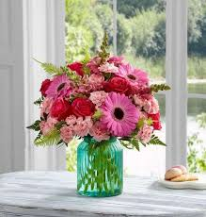
This coupon is good for

________________________________________________________________

Given to my mom with all my
love on Mother’s Day!

From ________________________

